Experiment: 10 5G Network Slicing Environment Using MATLAB
Objective 1:
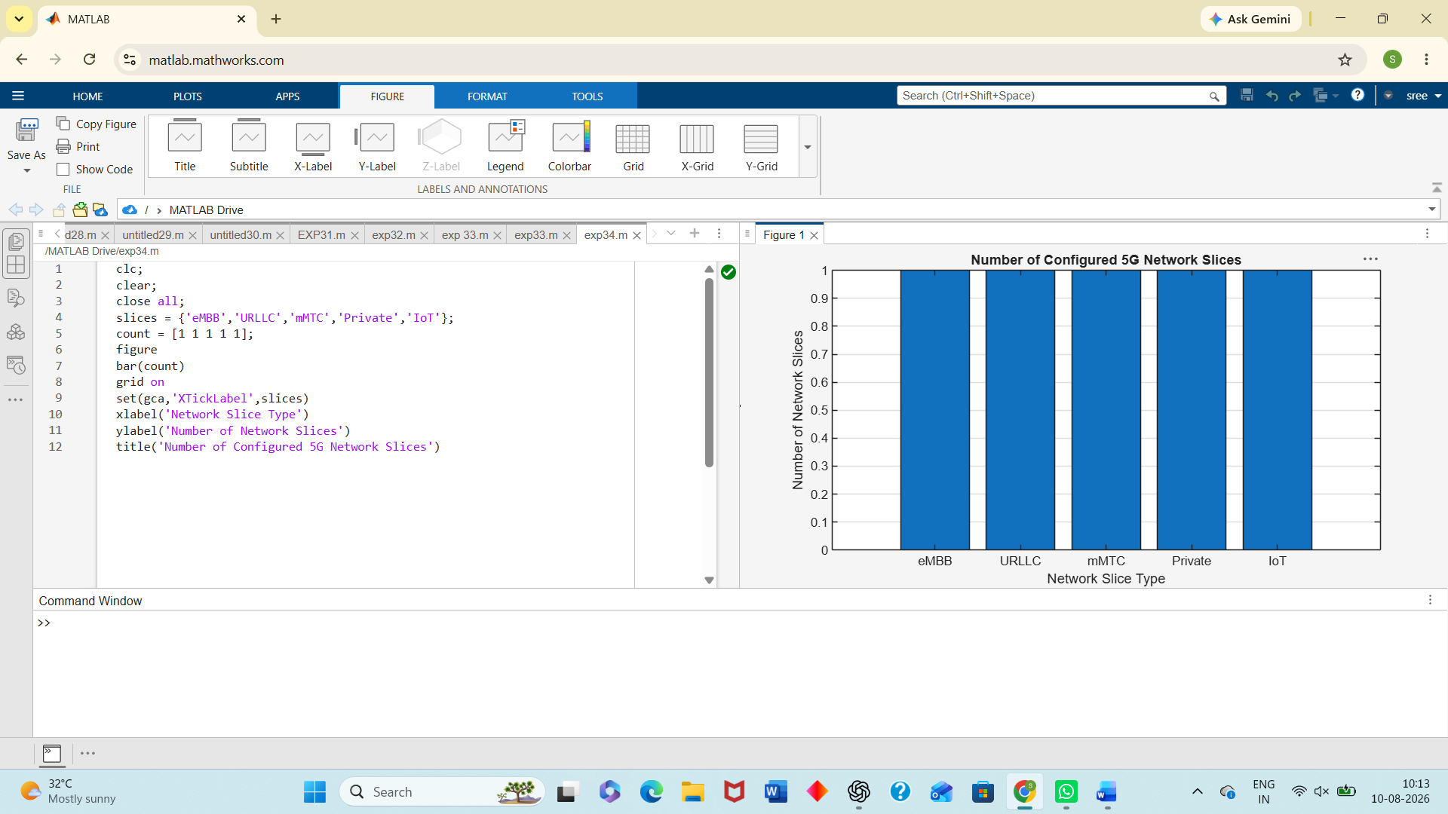
Objective 2:
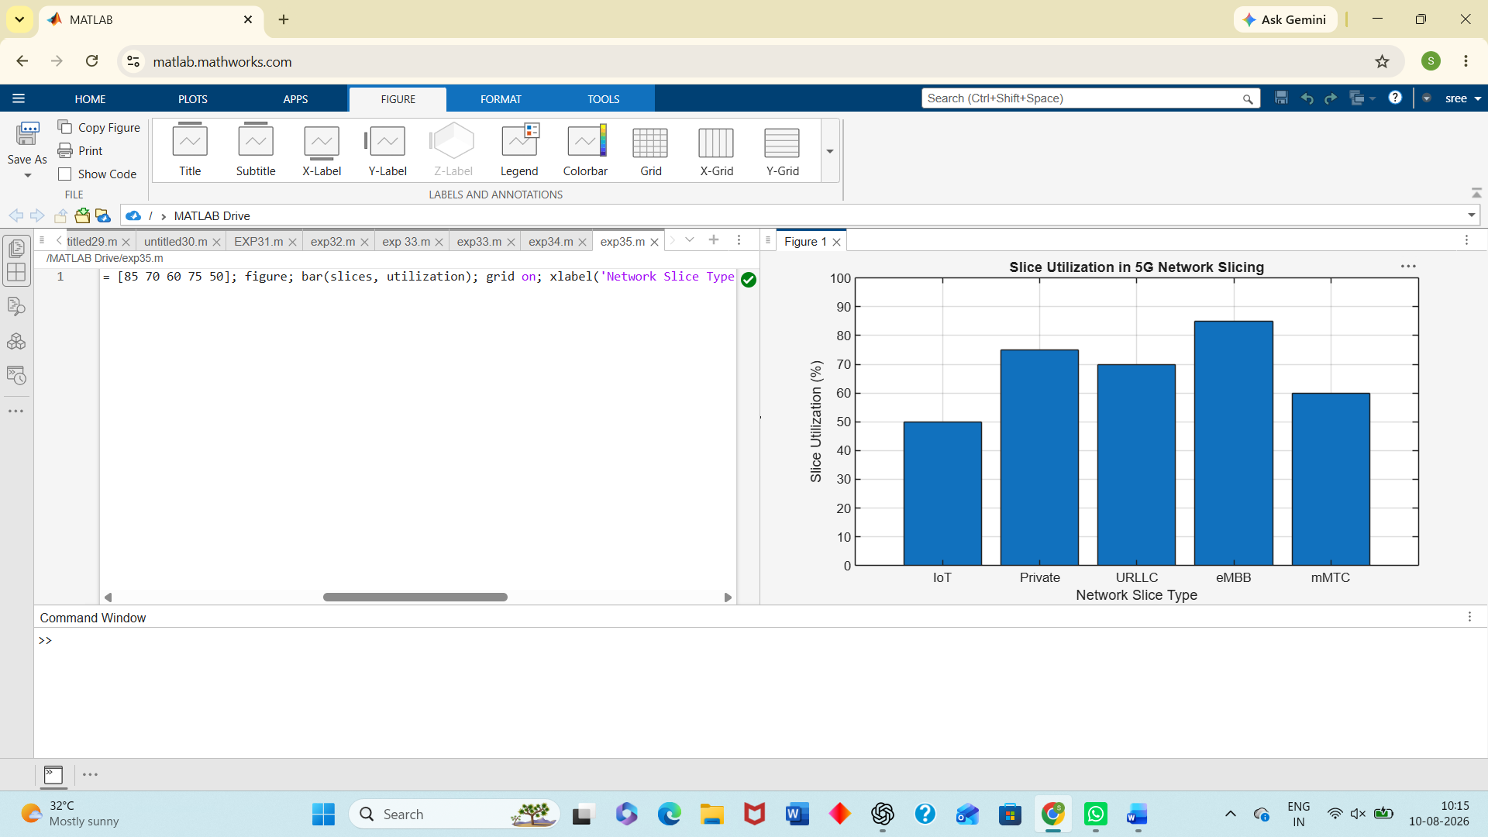
Objective 3:
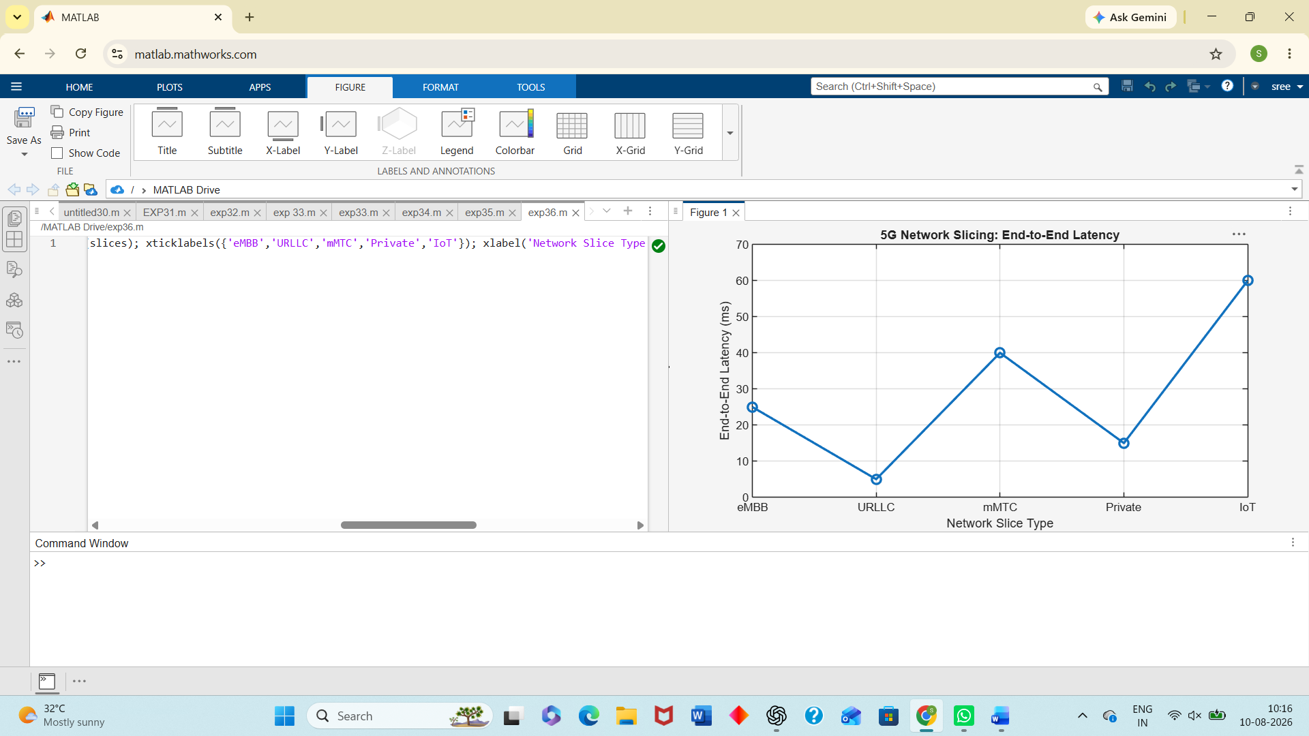
Result:
The MATLAB analysis successfully demonstrated the characteristics of a 5G Network Slicing environment. The results showed that multiple network slices can coexist while exhibiting different utilization levels and latency characteristics based on their intended services.

